**Sales Data Analysis 2011- 2013**

**Analysis of Total sales of products for the year 2011, 2012 & 2013**

* Data set updated with sub category & month wise sales for year 2011 – 2013
* Create Pivot Table
* Drag **products** to rows >> drag **sum of total sales 2011**, drag **sum of total sales 2012** & drag **sum of total sales 2013** to values
* Pivot table and pivot chart created.

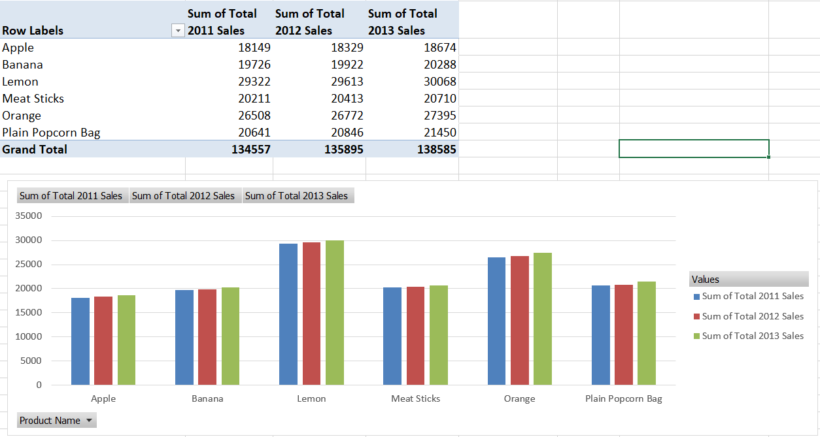

* Insert Slicer >> Select Temperature, Product Category & Sub category

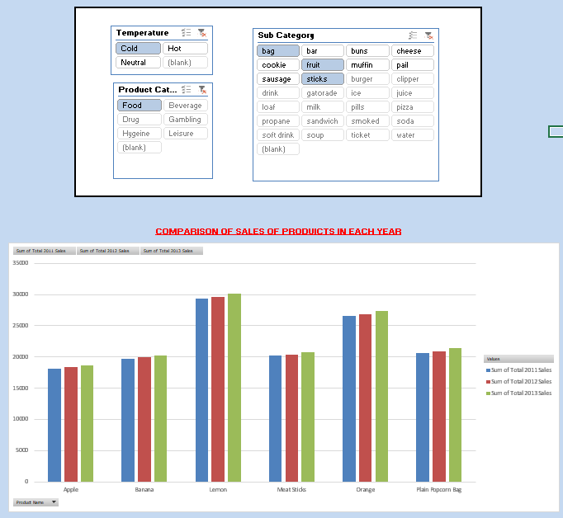

**Month wise Sales Analysis of the products for the years 2011, 2012 & 2013**

* Create Pivot Table
* Drag **products** to rows >> drag **sales of January 2011 to December 2011** to values
* Pivot table and pivot chart created.
* Interchange Axis fields to legend fields.
* Link slicer of Year wise chart with the Chart via Slicer >> Report Connections

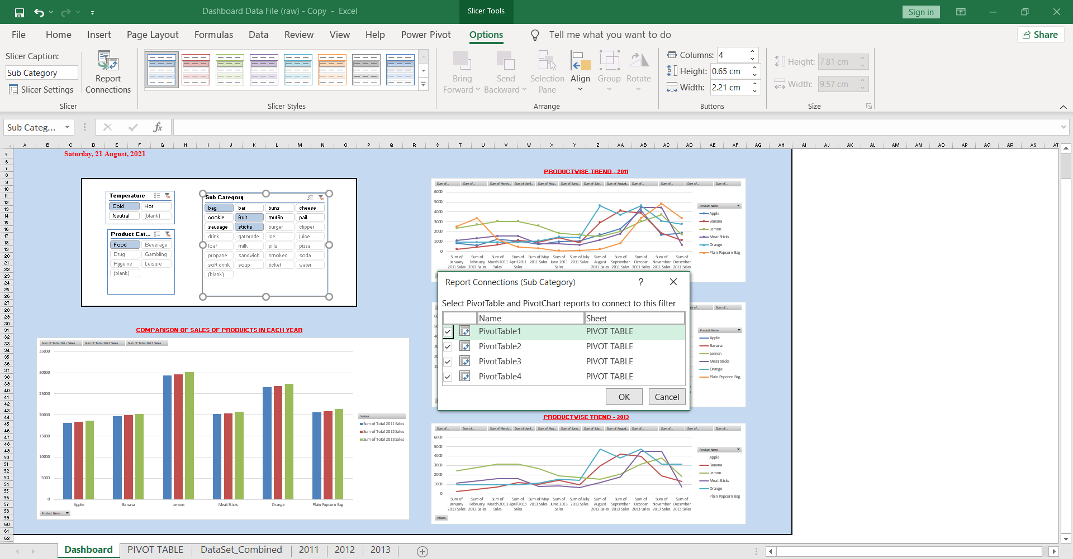

* Similarly created pivot chart for Year 2012 & 2013

Findings:

* Sales of products varied depending upon season & climatic conditions.
* Sales graph remained almost same for the years 2011, 2012 & 2013.
* Sales of cold products spiked in the months of August -September and decreased in June.
* Sales of Hot products spiked in the months of Dec-Feb and decreased in June- august
* The highest sales was marked by $1 Lottery in first half & by Chocolate chip cookie in the second half of the years
* $1 Lottery achieved $50k sales in the 3 years and remained the highest sold item
* While, $5, $10 & $20 Lotteries together achieved sales value below $4500
* Nail clipper & Strawberry milk remained the least sold items (around $600)
* Items with sales $2000 - Nail clipper, Strawberry milk, Chew, $20 Lottery, Allergy pills, Head pills, $10 Lottery, Cholocate milk & $5 Lottery
* Items with sales above $30k – Apple Cookie, BBQ Chip bag, Cappuccino, Chicken soup, Chocolate chip cookie, Egg & Cheese sandwich, Hamburger, Regular Chip bag, Lemon.